St. Peter Parent Teacher Organization (PTO)
Save the Dates 2025-26!

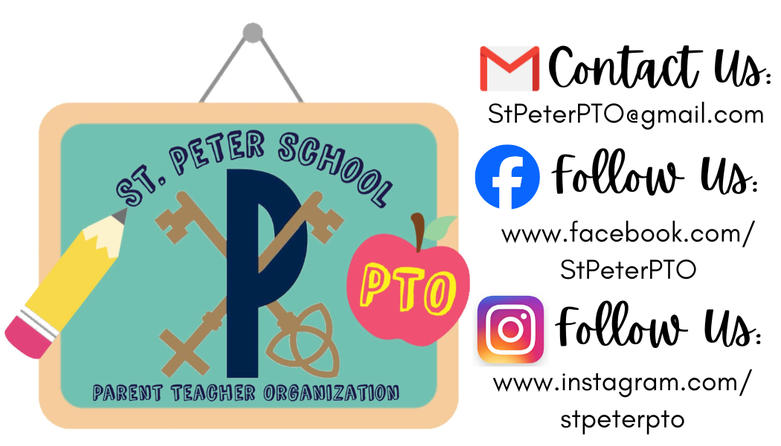 | PTO Open Meetings | August 26, 2025  Nov. 11, 2025  February 24, 2026  May 12, 2026  6:30pm in the Cafeteria | Please join us!  All are welcome!
 | Dayton Dragons Fundraiser Game | August 10th @ 1:05pm  Gates open one hour prior | End of Summer Bash rooting on the Dragons with school friends!
 | PTO Spirit Wear Sales | Fall Sale  August 6 - 22  Winter Sale  November 3 - 21  Spring Sale  March 16 - April 2 | Order your St. Peter PTO spirit wear  and show off your Panther Pride!
 | City BBQ  Dinner | August 22nd  (all day – bring flyer or show on phone) | Grab your dinner at City BBQ and mention St. Peter PTO!
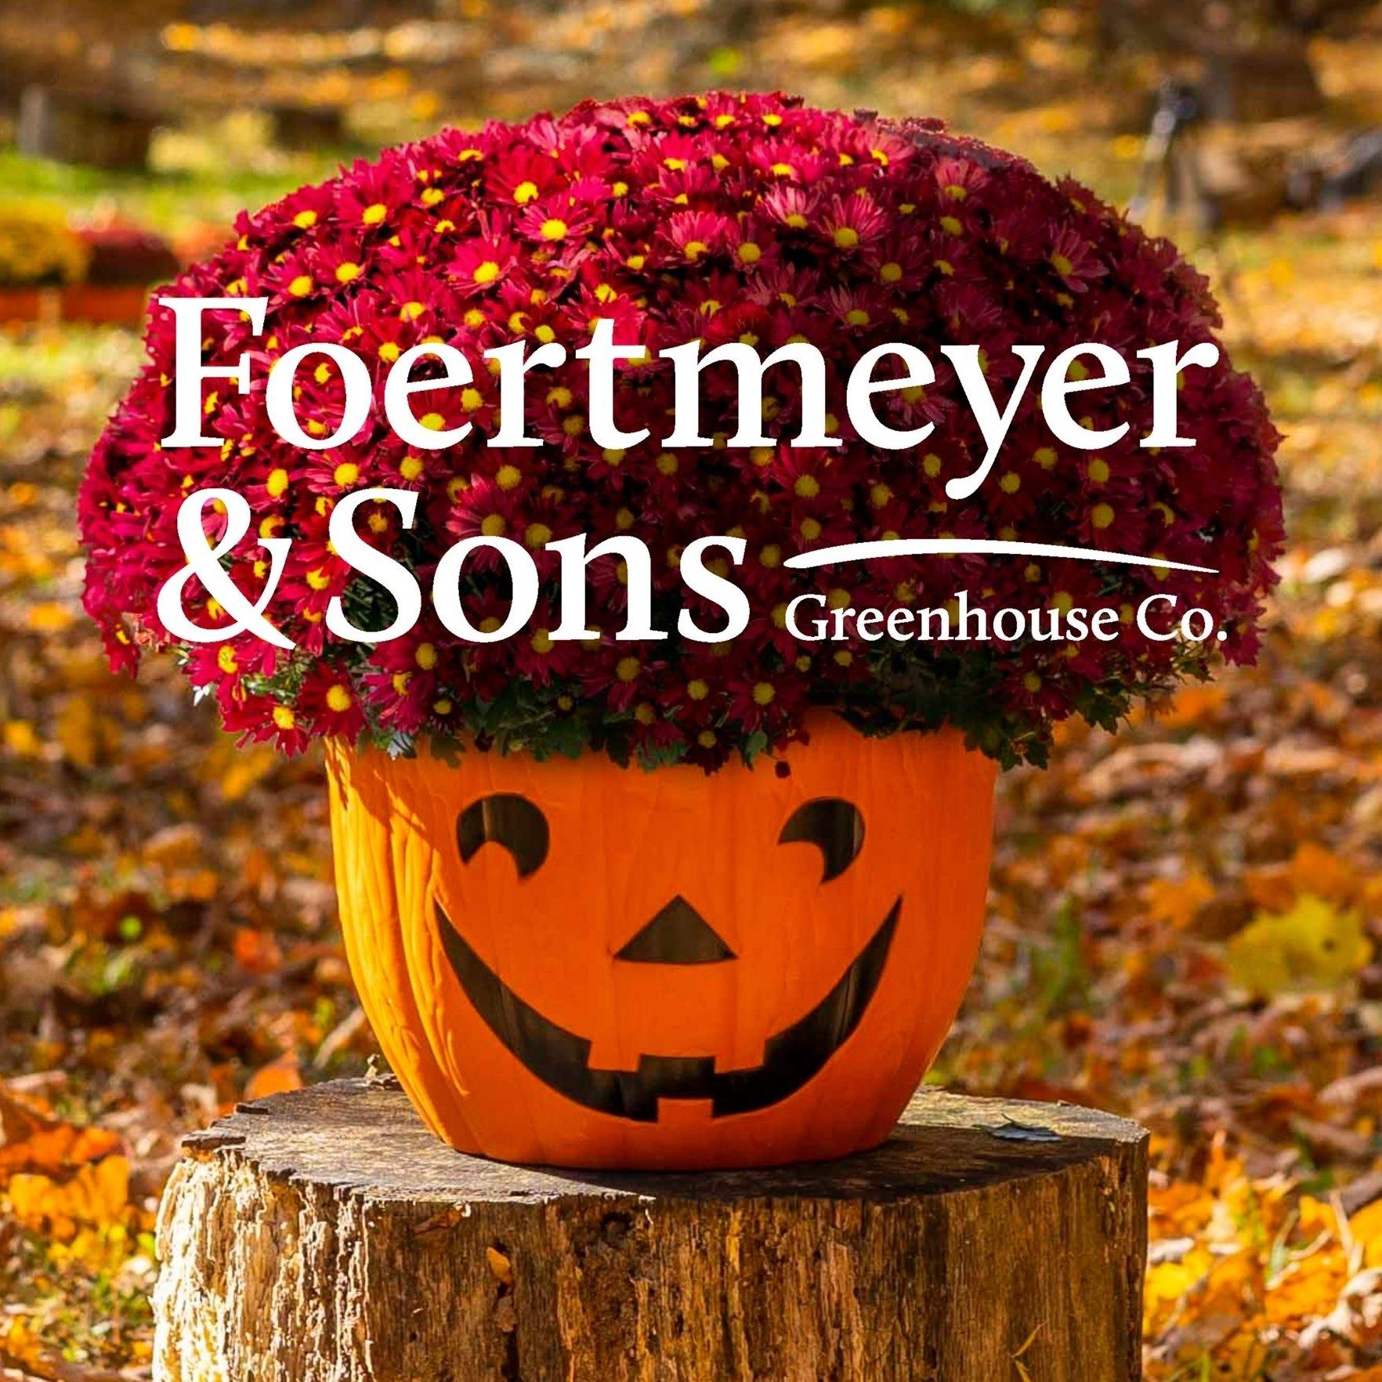 | Foertmeyer and Sons Mum Sale | Sale Starts  August 27  Sale Ends  September 10  Delivery Day September 26 | Your favorite fall fundraiser is back!  Volunteers needed for delivery day!
 | Firehouse Subs  Dinner | November 19th  (5-8pm – show flyer) | Grab dinner at Firehouse Subs (Old Troy Pk.)
 | Santa Shop | December 2-4  During school hours and the evening of Dec. 3 | Students can shop for gift items for family members!  Volunteers needed!
 | Jingle Mingle  Santa Breakfast! | December 13  From 10am - 12pm | Join us for our fourth annual Jingle Mingle!
 | Lee’s Famous Recipe Chicken  Dinner | February 16, 2026  (4-10pm – bring in fundraising card and give to cashier) | Grab your dinner at Lee’s Famous Recipe Chicken and mention St. Peter PTO!
 | Coffee and Donuts sponsored by PTO | March 15, 2026  After the 8:30am and 11:00am Masses | Come say hi to us in Fehrenbach Hall!
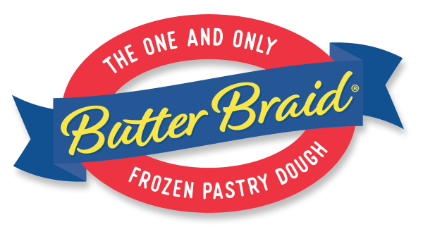 | Butter Braid Pastry Sale | Sale Starts  January 30  Sale Ends  February 20  Delivery Day March 12 | Delicious pastries just in time for Easter!  Volunteers needed for delivery day (dismissal-6pm)!
 | St. Peter PTO Dances | April 24  Daughters and a Date Dance  April 25  Son Plus One Dance | Enjoy an evening of dancing and fun with your son(s) and/or daughter(s)!
 | Old Scratch Pizza Dinner | May 6, 2026  (4-9pm, bring flyer, show on phone, or mention fundraiser!) | Grab your dinner at Old Scratch - Dayton and mention St. Peter PTO!

